UNIVERSITY OF ENERGY AND NATURAL RESOURCES
SUNYANI
SCHOOL OF SCIENCE

DEPARTMENT OF INFORMATION TECHNOLOGY AND DECISION SCIENCES,
BSc. INFORMATION TECHNOLOGY
TOPIC
WASTE MANAGEMENT SYSTEM
PROJECT PARTICIPANTS
KASSIM LATIF VIYE | UEB3293624
KOBBIAH PATRICK ADOMAKO | UEB3293324
ADARKWAH MARY | UEB32100724
ABDUL KAREEM SEIDU | UEB3290124
ANIAGYEI JUSTICE | UEB3297524

A PROJECT WORK SUBMITTED TO THE DEPARTMENT OF INFORMATION TECHNOLOGY AND DECISION SCIENCES, IN PARTIAL FULFILLMENT OF THE REQUIREMENT OF THE AWARD OF A DEGREE IN INFORMATION TECHNOLOGY
SEPTEMBER,2026

DECLARATION
This is to certify that the report presented by us in our final year project for our Degree in Information Technology programme at University of Energy and Natural Resources is our own work done to complete our degree programme. We Kassim Latif Viye, Kobiah Patrick Adomako, Darkwah Mery, Abdul Kareem Seidu and Aniagyei Justice hereby declare that the report submitted in our Final year project on the topic ‘WASTE MANAGEMENT SYSTEM’
is our own work.
SIGNATURE
DATE
KASSIM LATIF VIYE  UEB3293624 | 12/09/2026  ………………………… |   …………………………
KOBIAH PATRICK ADOMAKO  UEB3293324 | 12/09/2026  ………………………… |   …………………………
ADARKWAH MARY  UEB32100724 | 12/09/2026  ………………………… |   …………………………
ABDUL KAREEM SEIDU  UEB3290124 | 12/09/2026  ………………………… |   …………………………
ANIAGYEI JUSTICE  UEB3297524 | 12/09/2026  ………………………… |   ……………………
MR. SARFO-MANU PHILIP  (SUPERVISOR) | 01/09/2026  ………………………… | 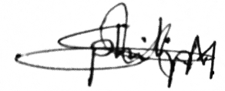  …………………………
DR. ANOKYE A. AMPONSAH  (HEAD OF DEPARTMENT) | ………………………… | …………………………

DEDICATION
This activity is dedicated to Almighty Allah SWT, for his great grace, protection, wisdom and strength in the entire academic work. His guidance and blessings are the most important things that enabled this project to be accomplished. We also pay tribute to our beloved parents and family for their unconditional love and prayers which have been the most of our inspiration and motivation. They are always supportive and a motivator for us to overcome many challenges and the one who assists us to move forward towards our teaching goals. Furthermore, this project could not have been realized without the advices, constructive comments and encouragement of " Mr. Philip Sarfo Manu " our supervisor. His knowledge and mentoring were incredibly important in the completion of this work. First of all we dedicate this work to our friends, class mates and all those who helped and supported us in any manner in our academic career. We hope this work can be an example of perseverance, commitment and pursuit of knowledge.

ACKNOLEDGEMENT
For if anyone seeketh wisdom, he shall ask of God: We express gratitude to Allah SWT and His Beloved Prophet (saws) for providing us with the strength and the wisdom to be able to do this work. We would like to thank our supervisor Mr. Philip Sarfo Manu for helping us with our project. Also, we appreciate all the lecturers who gave us support, motivation and guidance. Last but not least, we would like to express our gratitude to our parents for their emotional, spiritual and financial support, which also helped to make this project successful.

ABSTRACT
The project is an innovative Waste Management System to improve the efficiency and effectiveness of waste collection, monitoring and disposal works. The system is meant to be utilized both for the ease of the users to call for waste collection services as well as for the waste management teams to manage, track and monitor the waste collection procedure. The application's user-friendly and easy-to-use interface simplifies waste management processes and promotes environmental responsible behaviour of the users. This system adds additional value to improve the operational efficiency and accountability including user registration, request for pick up, service history tracking, reporting and notification. The app will improve waste management, make it easier to collect and dispose of waste, and help to promote environmental sustainability.

TABLE OF CONTENTS

DECLARATION ii
DEDICATION iii
ACKNOLEDGEMENT iv
ABSTRACT v
TABLE OF CONTENTS vi
LIST OF FIGURES ix
CHAPTER ONE 1
INTRODUCTION 1
1.0 Background of the Study 1
1.1 Problem Statement 3
1.5 Scope of the Study 5
CHAPTER TWO 6
LITERATURE REVIEW 6
2.0 Introduction 6
2.1 Concept of Waste Management 6
2.2 Traditional Waste Management Practices 7
2.3 Smart Waste Management Systems 7
2.4 Existing Waste Management Systems 8
2.4.1 Role of Information Technology in Waste Management 10
2.5 Waste Management in Ghana 10
2.6 Public Participation and Environmental Awareness 11
2.7 Circular Economy and Sustainable Waste Management 11
2.8 Research Gap 11
2.9 Summary of Literature Review 12
CHAPTER THREE 13
METHODOLOGY 13
3.0 Introduction 13
3.1 Software Methodology 13
3.2 Agile Methodology 14
3.3 Key Principles of Agile 18
3.4 The Rationale Behind Agile Methodology 20
3.4.1 Tools 23
3.5 Process Flowchart & Entity Relationship Diagram 24
3.5.1 Entity Relationship Diagrams 25
3.6 System Requirements 26
3.7 Functional Requirements 30
3.8 Non-Functional Requirements 32
3.9 System Design 33
CHAPTER 4 36
SYSTEM IMPLEMENTATION AND RESULTS 36
4.0 Introduction 36
4.1 Sign Up Page/ Login Page 36
4.2 Customer Dashboard 37
4.3 Request Pickup Page 38
4.4 Service History 40
CHAPTER FIVE 42
CONCLUSION 42
5.1 Conclusion 42
5.2 Future Works 43
REFERENCES 44

LIST OF FIGURES
Figure 1 Agile Diagram 14
Figure 2: Flowchart 24
Figure 3: ER Diagram 25
Figure 4: Signup/Login Page 37
Figure 5: Customer Dashboard 38
Figure 6: Request Pickup Page 40
Figure 7: Service History 41

CHAPTER ONE

INTRODUCTION

1.0 Background of the Study
The study was conducted to gain background information. With the ongoing process of urbanization and industrialization, waste management has become an increasingly critical problem affecting the environment, public health and the economy. Population growth, urbanization and changing consumption patterns are the key factors contributing to the rising amount of solid waste globally (Kaza et al., 2021; UNEP, 2021). The right systems of disposal of waste are now in place - at least in theory and now we are putting them into practice. Therefore, the process of throwing away something as trash. Throwing away landfill and allowing to destroy the environment and harm one's health is no longer an adequate response to it (Wilson, Velis and Cheeseman, 2020). Digital technologies can, on the other hand, be used to enhance the existing waste management practices and to ease waste collection monitoring and processing (Zhang & Chen, 2021). Research across the globe has revealed a growing need for technology to help manage waste – year by year. It makes decision-making easier with data and at the same time promotes environmental protection. In addition, smart waste management has the potential to improve the efficiency of operations, minimize environmental hazards, make waste management transparent, and consequently facilitate accountability (Kumar et al., 2020; Singh & Kumar, 2020). Furthermore, digital technologies like real time monitoring, automated reporting and geolocation tracking can give an even more thorough insight into the "right at that moment situation" in waste management and make it easier to pinpoint areas where illegal waste disposal is more likely to occur. (Alwaeli et al., 2019; Longhi et al., 2020).
In the developing countries such as Ghana, there has been a considerable amount of waste, resulting from urbanisation and the development of commercial activities. This waste comes from the normal life and business activities. Therefore, the city is facing challenges in its waste management. The major environmental factors are an inadequate knowledge of disposal methods and an absence of suitable littering deterrents, as well as recycling facilities. These problems not only impact the environment, but can also threaten public health. (Asare et al., 2021; Agyeman & Boateng, 2023). The integration of technological solutions which may reinforce existing waste management activities has been mentioned as being very important in this area of concerns. The overall support for public protection of the environment should be reasonably assured by this innovation. The proposed project is designing and developing the waste management system in order to enhance the efficiency of waste management system, its accountability and optimize the processing of the waste. The proposed system will integrate data management and monitoring systems, and automate reporting systems to support proper waste segregation, scheduled pickups and proper waste disposal. This system will also aid in the implementation of conventional manual systems and further reduce environmental risks (Batool & Ch, 2019; Banguera et al., 2021). Modern waste management systems are creating the concepts of Smart Waste Systems and Sustainable Urban Planning. This includes automatic scheduling, analytics dashboards and GPS tracking which could provide the necessary tools for authorities to better deploy resources and respond to the environment in real-time as demonstrated by Sharholy et al.
Public reporting systems and notifications are effective to improve public participation and better compliance to waste management regulations (Yadav & Samadder, 2020). Furthermore, the waste management is structured and interlinked, and it allows recycling and circular economy, thanks to the provision of reliable data in terms of waste generation and waste disposal. These help officials to create recycling initiatives, minimize landfills, and encourage sustainable resource use (Geissdoerfer et al., 2020; Hoornweg & Bhada-Tata, 2018). The insights gained from this can contribute to improve environmental performance and long-term environmental sustainability in cities (OECD, 2021). Although the world has progressed a long way in waste management technology, there are communities that are lagging and facing problems with obsolete waste management systems and infrastructure. Therefore, this research aims to create a holistic waste management system that will preserve the environment, enhance the system's efficiency during its operation and involve community in sustainable waste management (World Bank, 2021). by Rehman, Khan, Gupta, Bhatia, Ariharat, Çehre, & Asiri, (2018) and Kumar et al., (2020).

1.1 Problem Statement
Along with the population and economic activities increasing over the world, especially in cities and communities, the amount of solid waste has also been increased in these regions (Kaza et al., 2021). (Kumar et al., 2020). The conventional solid waste management practice is mainly labor intensive and fixed solid waste collection timetable which results in among others non-collection of waste periodically, overflow of the bins and illegal dumping of waste (UNEP, 2022). The lack of incorporation of technology could limit to ability of the waste regulatory body to properly keep tracks on the amount of waste generated, monitor waste collection process and effectively enforce the waste management policy (Zhang & Chen, 2021). Besides this, low community involvement in waste segregation and recycling process (Yadav & Samadder, 2020) due to lack of communication between waste provider and the community was also observed. Consequently, recyclables’ contaminated waste from the household waste thus putting pressure on the landfill site and the environment (OECD, 2021). Moreover, records of the solid waste management activities are incorrect and dated resulting in difficulties and challenges during the planning process and decision making. Regenerative data is very basic if you wish to optimize the routes used, resources allocation and assessment of the collection (Longhi et al., 2020). Moreover, it is a challenge to waste manager in improving this situation which increase the cost of waste operations, the GHGs and the other impacts of the environmental (UNEP, 2022). Hence, a single solid waste management with a technological driven system and monitoring, data management and community participation system is a must in order to improve the effectiveness of solid waste management and sustain and environmental protection (World Bank, 2021).

1.2 Aim of the Study
The main goal of this project is to implement and develop a technology-based waste management system to help in the efficient collection of waste, increase monitoring and reporting of the waste system and promote sustainable waste management practices.

1.2.1 Specific Objectives

- To create and establish a centralized application for waste management to record, manage and monitor waste collection/disposal activities.
- To facilitate real-time tracking, reporting and communication of waste collection to enhance the coordination between the waste management authorities and community members.
- To embed waste segregation, waste recycling management and automated reporting, to move towards sustainable waste management and support for decision making.
- To evaluate the efficiency of the designed system to improve the efficiency of the waste collection process, reduce delays in operation and pollution in the environment generated.

1.3 Significance of the Study
The study is designed to analyse the significance of project. This study is a contribution to the areas of environmental sustainability, health improvement and smart cities. It will assist the waste management authorities in taking better decisions and make them more efficient in managing the waste by providing them data driven insights (Singh & Kumar, 2020). It also increases awareness of the public and encourages waste disposal that is more environmentally friendly, and sets the grounds for embedding technology into environmental management systems (Geissdoerfer et al., 2020).

1.4 Scope of the Study
The study basically aims at implementing a computerised waste management model in urban and semi-urban areas. Waste collection tracking, reporting, monitoring and data management will be included in the system. The research is not about technologies for processing of physical waste, recycling machines etc., but about digital coordination and operation management.

1.5 Organization of Work
This study is comprised of five chapters. This chapter contains introduction to general problem and overview of the research. In Chapter Two the important literature and previous studies concerned with Waste Management Systems are reviewed. The research methodology applied is explained in chapter Three and a summary of research methodology applied in the design approach of the system is given in chapter Three. Chapter four provides a detailed approach on system implementation, test procedures and results of the tests. Finally, chapter Five gives a summary of the findings and the conclusions of the study and recommends ways in which the study might be improved in future.

CHAPTER TWO

LITERATURE REVIEW

2.0 Introduction
Literature pertaining to waste management systems, digital waste management technology, smart city application and public involvement in environmental management are reviewed. The literature review aims to offer a background information on the development of the technology-based waste management system, whether theoretical or empirical. It assesses the existing studies, identifies research gaps and presents how the issues of today challenging waste management operations could be addressed through modern technologies.

2.1 Concept of Waste Management
Waste management is the management process of collecting, transporting, processing, recycling and disposing of the waste materials in a manner that minimizes impact on the environment and public health. Waste management is one tool towards achieving sustainable development and urban sanitation. The inadequate management of waste is a source of soil pollution, water pollution, air pollution, and transmission of infectious diseases, according to the research. With rapid population growth and the increase in urbanisation, the quantity of waste produced on earth has increased significantly (Kaza et al., 2021). However, despite economies and consumption patterns, waste generation keeps on increasing, according to World Bank. Consequently, governments and municipalities are turning to new ideas for making waste management more efficient and environmentally-friendly. A number of problems and challenges can arise in the implementation of a waste management system including the lack of infrastructure, particularly in developing countries; lack of financial resources to invest in implementation or maintenance; poor waste collection systems; and lack of monitoring (UNEP, 2021). The restrictions make it even more important to introduce waste management innovations via technological solutions.

2.2 Traditional Waste Management Practices
Lack of adequate waste management systems is mostly manual, on a fixed collection and paper tracking systems. They have been operating for many years, but have experienced a wide range of operational challenges including low coordination, late reporting, and transparency challenges (Wilson et al., 2020). Manual approaches are not able to effectively monitor waste collection. Garbage cans may fill up sooner than the pickup time, causing illegal dumping and possible environmental contamination. Moreover, they are not effective in the management of resources, as they lack the ability to react to the actual waste flow, having fixed programmes (Longhi et al., 2020). The traditional approaches for waste management are found to be inadequate to address the ever-growing demands of the fast-growing cities. Hence, the importance of the automatic and intelligent waste management systems has grown.

2.3 Smart Waste Management Systems
Smart waste management systems utilise digital technologies such as the use of sensors, databases, cloud computing and mobile applications to improve the efficiency of waste collection and monitoring. These are the systems that assist the waste management companies in monitoring the position of their collection trucks, bin level and can produce real-time report and analytics (Kumar et al., 2020). Technology-driven waste management platforms can help to replace manually managed waste management processes with a centralized system. As regards the addressing of environmental problems, real-time monitoring means that they can respond immediately. However, optimization of waste collection routes based on actual quantities of waste was achieved by using the real-time monitoring tools (Zhang & Chen, 2021). They can reduce fuel consumption, reduce costs and improve service provision, as well as providing other benefits. The United Nations Environment Programme (UNEP) has said that digital technologies are a key part of the efforts to enhance waste management, and are contributing to sustainable urban development (SUD). Moreover, environmental monitoring and urban planning are interrelated and an important element of smart cities, smart waste systems.

2.4 Existing Waste Management Systems
There have been several waste management systems in place before this to enhance the collection, monitoring, transportation and disposal of MSW. The traditional waste management systems are mainly reliant on the fixed collection time for waste, manual inspections of waste bins, and paper documentation. These are solutions that are popular, but have the issues of wasting the time and effort of a poor waste collection system, overfull bins, high cost of operation, and environmental pollution from late collection. However, in view of the challenges encountered, researchers and organisations have created smart waste management systems using cutting-edge technologies like the Internet of Things (IoT), GPS, Mobile Applications, Cloud computing and Artificial Intelligence (AI) to enhance waste management processes (Sosunova & Porras, 2022). The most popular one of the present systems is Smart Waste Management System using IoT. The key of this system is the ultrasonic sensors attached to waste containers which are used to measure the level of waste in real time. A preset level is automatically triggered to notify waste management authority when the level of waste reaches a certain point, all without requiring any human interaction. This data is then displayed on a monitoring dashboard on which waste collection routes can be optimized. This will help to lower the use of fuel, avoid unnecessary trips by collection trucks, lower operating costs and avoid waste bins overflowing. Sosunova and Porras (2022) concluded that the waste management solutions based on IoT have significantly increased the efficiency of waste collection, as they continuously monitor the waste and make timely decisions based on the information they have.
GPS-based Waste Collection and Fleet Management System is also a popular system. This is one way, where the waste truck comes with a GPS device, and the administrators can see the real-time location and movements of the waste truck. To reduce the distance, time and fuel needed for waste collection, the shortest and most efficient routes for waste collection are determined by route optimization algorithms. The system also provides greater accountability as supervisors can verify if collection vehicles have been to particular locations. The downside of these benefits is that while GPS-based systems have no point-to-point communication between residents and waste collectors, the task of real-time reporting of overflows and illegal dumping events is challenging for citizens (Kannan et al., 2024).
Waste management systems based on mobile applications have also been developed, where they enable connection of the residents directly with the waste management service provider. These are systems which allow citizens to request waste collection services, schedule waste collections, report illegal waste disposal, make a complaint and be notified on the schedule of waste collections. The waste collector can make requests on their cell phones, and their waste collection status is checked once it is completed. Implementation of mobile apps to facilitate citizens and service providers and expedite service delivery. The current mobile systems, however, have limited scope and only include reporting and scheduling services and do not include smart monitoring devices like smart bins and automated route optimization (Wirani et al., 2024).
The smart waste management systems using AI have been gaining significant recognition in recent years. These are potential process applications of AI to predict waste generation patterns, automatically classify waste types, optimize schedules and improve decision making. Machine learning algorithms are used to analyse the historical data of waste and to forecast future waste volumes that are sent to the municipality, thus optimizing resource use. AI also has been leveraged by image recognition systems to automatically sort and recycle waste.

2.4.1 Role of Information Technology in Waste Management
IT can contribute a lot in waste management systems in the modern world. The data repository can be stored on an online platform and automated reports generated online, along with real-time monitoring. The technologies help to bring transparency and also aid in data-driven decision-making (Singh & Kumar, 2020).
With GPS tracking, mobile reporting and analytics dashboards would allow waste management companies to identify non-efficiency in waste management and what to do about it. Manual systems can also mean there is a huge amount of potential for human error and record inaccuracies which can result in an effective waste management system that is less effective (O'Hara 2018).
The utilization of IT solutions has been proven to positively affect waste management and optimise operations and minimise the negative impacts on the environment (Sharholy et al., 2020).

2.5 Waste Management in Ghana
The rapid urbanization and population growth in Ghana is still a major problem in waste management. Research has demonstrated that differences exist among urban centres with respect to waste collection practice, open dumping and waste recycling practice (Asare et al., 2021).
The lack of effective monitoring systems and public engagement tools are part of the reason for poor waste disposal practices. Some studies have shown that mobile reporting platforms and digital monitoring tools can help coordinate waste management and boost the involvement of communities in sanitation practices (Agyeman & Boateng, 2023). Waste management is a problem which is being gradually solved using technology. Digital systems are a means to enhance communication between the authorities and the residents and foster transparency and accountability in the waste collecting process.

2.6 Public Participation and Environmental Awareness
The participation of the public and awareness of the environment (2.6.01 – 2.6.04). A good waste management system requires that public does play crucial role. (Yadav & Samadder, 2020).
The residents can use technology driven platforms to report sanitation issues, be notified and receive environmental education materials. The features encourage the involvement of the community and cooperation between citizens and authorities.
The findings of the research showed that WMS with tools that engage the public have a greater long-term sustainability performance than traditional WMS without public participation (Geissdoerfer et al., 2020).

2.7 Circular Economy and Sustainable Waste Management
Modern waste management systems which foster waste reduction, re-use and recycling promote the circular economy principles. With good data collection, the trend of waste generation can be assessed, and waste recycling programs can be created, which are efficient (OECD, 2021). Circular economy (CE) strategies reduce the amounts of waste being sent to landfill and the sustainable use of resources. The main goal of waste management systems is to sustainably use technology to monitor the flow of recyclable waste and maximize the recycling process to ensure the conservation of the environment and sustainable urban growth.

2.8 Research Gap
Previous studies have investigated waste management problems and smart technologies, however, most of the existing solutions are mainly targeted to large industrial applications and not to the concept of digital solutions for urban communities. There is still a low level of adoption of centralized digital platforms in many developing regions that combine elements of waste monitoring, reporting and public engagement. Furthermore, many waste management companies are yet to adopt and are still using manual processes and cannot process data in real-time. Therefore, the aim of this project is to address this gap a technology based system for waste management that is more efficient, transparent and will engage the community in urban and semi-urban waste management.

2.9 Summary of Literature Review
Based on the literature, reviewed in this chapter, it is worth to note the importance of modern waste management systems in the promotion of environmental sustainability and improvement of public health. There is an increased amount of waste generated and the waste management system is not efficient enough to handle the increasing amount of waste, so the current way of managing waste is no longer effective. For smart waste management systems, digital technologies can be the answer, because these systems can be used to enhance monitoring, reporting, and decision-making processes. Public engagement and data analysis, in addition to principles of circular economy, are also highlighted as the major aspects that can lead to the achievement of a sustainable waste management outcome. Despite advancement of the world, there are problems of lower rate of technology use in some parts of the developing world such as Ghana. Thus, the establishment of a digital waste management system in one place is an opportunity to increase the efficiency of work and create sustainable conditions for development of the city.

CHAPTER THREE

METHODOLOGY

3.0 Introduction
If the activities proposed by the Waste Management System are to be carried out efficiently and effectively in order to achieve the desired results the use of a systematic and structured approach proved vital. The project's software development process is described and the principles of flexible software development process – in the Agile way of development – with collaboration and continuous improvement (Sutherland & Schwaber, 2019) – are explained. The reasons for choosing agile methodology were due to the iterative nature of the methodology which allowed for frequent test, feedback and improvement of the features of the system as per the user and stakeholder needs (Moe et al., 2018). The chapter covers the various stages of development (planning, analysing, designing, implementation, testing and deployment) and discusses the practices, techniques and tools used during the execution of the development process. It also gives an explanation of the "how" and "why" on how the methodology has been used, and how it has assisted in the successful development of the system. The overall goal of the project was to develop a platform for waste management that is efficient, reliable and user friendly, which can be utilized to improve the processes of waste collection, monitoring, reporting and disposal, and which can foster environmental sustainability and operational efficiency (Pichler, 2019).

3.1 Software Methodology
The methodology used in software is a systematic and organised approach to planning, design, testing and development and maintenance of software-based systems. It is a collection of principles, techniques, tools and procedures which are followed by software developers all the time in the Software Development Life Cycle. Having a software methodology in place can ensure the desired system that is produced at the end of the project fulfils the requirements of the user, is efficient, and is completed within the project's time and resource limits. Implementation of waste collection, monitoring and reporting functions was one of the key aspects that made the solution for Waste Management System (WMS) project reliable, user friendly and efficient.

3.2 Agile Methodology
Agile methodology is a flexible software development methodology for building software in an iterative way which focuses on collaboration and continuous feedback and incremental delivery of working software. This enables the developers to work on small steps known as iterations, and to go through the development process in shorter cycles, test and update over time. The Waste Management System has been developed via Agile and this allowed the flexibility that would allow for the evolving needs and feed-backs from the stakeholders. In the Waterfall approach Developer and the User can't communicate at every step and the system is to be developed in such a way as to meet the needs of the User for its use. This will be useful for developing a Waste Management System that will provide efficient waste management, user friendly service and environmental sustainability.
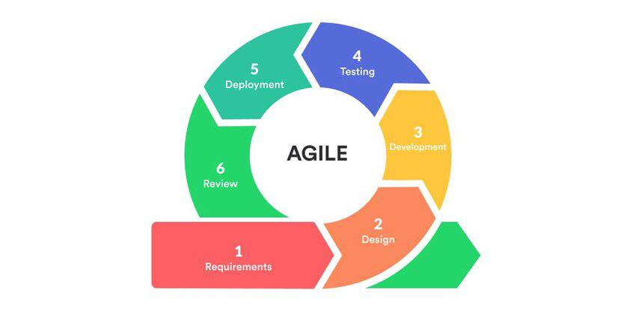
Figure 1 Agile Diagram

Agile Methodology in System Development source: Okeke(2021), retrieved from https://targettrend.com/agile-methodology-meaning-advantagesdisadvantages-more.
- Requirement Gathering
The process of gathering requirements for the Waste Management System was a continuous one, with the potential users, waste management staff and other stakeholders collaborating in the process. The aim was to find out the problems of conventional waste management and the characteristics necessary to make the operations more efficient. The users' needs and requirements are determined through consultation, discussion, which cover Waste Collection schedule, Waste tracking, reporting and record management. These requirements were given in the form of user stories and prioritized on the product backlog. The requirements were tossed in many more details; changed as the project progressed; and were identified by the stakeholders, with the assistance of an agile methodology for the requirements.
- Design
Design phase of the Waste Management System was the development of a solution that will be simple, efficient and easy to use. Zones were first outlined in a high-level system architecture to support the description to highlight the fundamental components of the system and clarify role functions such as user management and waste collection management, reporting and database integration. As each iteration of the development process took place, detailed design of each module was designed based on the selected requirement. A flexible approach has been developed by Laguna: changes to the user interfaces, processes and system functions have been done based on feedback and test results of the users.
- Development
The Waste Management System has been developed by using an iterative approach. The features were gradually designed and started to be used for the core functions like Waste Collection Record, User Registration, Waste Category Management, Waste Report Generation etc. This was made around the concept of being incremental, meaning one incremental step was fulfilled that had to be functional and working prior to the next step. To make the running seamless and to alleviate the issue of compatibility, the CI approach was followed into integrate new modules of the system into the existing system components. During the development, feedback was received on a regular basis from the stakeholders which helped to improve and refine the development.
- Testing
The functions of the Waste Management System have been tested during its evolution to ensure that the system is functional and meet the users' needs. There were different ways in which tests were conducted, such as Unit Testing (tests a single module to identify if it is functioning correctly), and what is being tested, such as Integration Testing (tests the modules as a whole to see if they are functioning correctly) and System Testing (tests the entire system to see if it is functioning correctly). Additionally, for all new features added, regression testing was also done to ensure that no other feature was impacted. The continuous testing allowed for the identification and resolution of errors, thus enhancing the reliability and quality of the final system.
- Deployment
The process of making the implemented Waste Management System usable to the intended users was called as deployment. Successfully tested, installed and configured the system into the environment. The development pattern used to help achieve continuous deployment, testing and implementation of features as they were done is agile principles. The feedback from the user during deployment was used to make the last-minute adjustments and improvements. The deployment process made sure that the system was fully functional and could support waste management processes like waste collection monitoring, data management, and reporting. The advantage of what's used is that it's an efficient system for streamlining the waste management activities and encouraging environment-friendly management.

- Review Sprint
Review Every end of the iteration, Sprint review was conducted where the work of Waste Management System was reviewed. The purpose of the review was to look at what has been implemented with the functionalities, gather comments from the stakeholders and assist in decision making for future enhancement. The development team presented the features that they've developed in this sprint in the review – Waste Collection Management module, Waste Category tracking module, User Management module, Report Generation module. User and stakeholders’ usability, functionality and performance data about system was collected. The potential improvements to features, UI and process were discussed and recorded. The product backlog was adjusted, and reprioritized, based on the feedback, to make sure that the next development activities would include the most important user requirements. The Sprint-time review process ensured that development team and the stakeholders kept up to date on the direction of the Waste Management System and, consequently, the Waste Management System was developed with the user's needs and project goals in mind. The cycle of assessment resulted in an improved waste management solution, which is more effective, reliable and convenient to use.
- Launch
Features in the Agile can be introduced in different stages of the project in the Waste Management System, depending on the readiness of the system for the features introduced. It has been developed several times before finally creating a “Minimum Viable Product” (MVP) with the least number of features involved and still test and deploy the system. The MVP was intended to have essential features such as the waste collection management, user registration, waste category management, and report generation. A few users/stakeholders were then introduced, tested and gave feedback on the system. With the early release, users had the opportunity to use it in their natural setting and to give feedback on how easy, fast and usable the system is in their context. This phase information was used to redefine the areas considered as problems to be worked on, as well as to offer areas for future iterations of development. By applying this approach of incremental launch, the Waste Management System was continuously improved, refined and ultimately accepted by the user and favourable to the implementation of the waste management system.

3.3 Key Principles of Agile
Agile is predicated on a set of key principles. Agile has a set of key principles. The Agile methodology is based upon the Agile Manifesto that emphasizes four values that are vital to the process of successful, agile software development. The above principles have been followed continuously in developing the Waste Management System in an attempt to improve and make it user friendly.
Processes and tools: Communication and collaborative efforts among the system developers, stakeholders and users were emphasized, such that the needs of the system are understood by everyone and appropriate actions are taken to meet the needs.
1. Comprehensive documentation vs working software: Documentation was developed as reference and reporting document while the primary focus was to provide a working Waste Management System to facilitate waste collection, tracking, reporting and monitoring.
2. To work through software, rather than just reading through detailed documentation: The system is developed step-by-step in connection with the different stakeholders in the contracting process, thus evolving the system based on real needs and feedback from the customers.
3. Getting ready to respond to change after a plan: The development process was flexible and changes were made in system features and requirements when new information and insights were gained throughout the project's life cycle.
The Agile development approach offers a number of advantages for the Waste Management System: IDP's for the Waste Management System:
1. Flexibility: Agile had the flexibility to incorporate new requirements and user feedback that could be incorporated to improve the system further (such as improved reporting/tracking).
2. Faster Delivery: The Waste Management System, including the waste registration system, collection planning and reporting, was designed and implemented early, to allow early feedback and refinements.
3. Continuous Improvement: They constantly evolved the system during their frequent sprint reviews and feedback to make it more efficient, user-friendly and effective in managing the waste stream.
4. Collaboration: Communication between developers and stakeholders is one of the most crucial Agile principles that must be adhered to, where both are in tune with each other and do not miscommunicate.
Implementing the Agile approach in project management.
Using agile tools for project management.
To effectively manage the development of the Waste Management System using the approach of Agile methodology, several tools were used:
Task management, tracking of progress, organisation of product backlog, sprint tasks: Trello or Jira.
Microsoft Teams: Slack/Microsoft Teams: To support the communication between team members and other stakeholders in the development and review process.
Grounded: Used for version control, code collaboration and development flow optimisation with the aim of ensuring proper tracking and management of all changes to the Waste Management System.
Conclusion
The agile methodology is well suited for the development of the Waste Management System since it involves software development that is flexible, has constant feedback, and is iterative. The critical parts of the system, including the interaction with users, reporting, tracking of waste and management of waste collection were developed incrementally, with each part of the development process called a sprint. The project was broken up into smaller and smaller pieces called sprints which were developed one after another, with the major aspects of the development, such as waste-tracking, collection management, waste-reporting and user interactions, being added throughout the project. The process was iterative, it was suggested to continually improve and adapt the system to better meet stakeholders' needs and wants as these evolved, resulting in a more user-friendly and efficient system. In conclusion, Agile has helped develop an adaptable, reliable and user-friendly Waste Management System that can cater to user needs and promote sustainable waste management practices.

3.4 The Rationale Behind Agile Methodology
A highly appreciated model in software developing framework is waterfall model, which is very rigid and can be produced with delay, high cost, and not fully meeting users' requirement; thus, it is transformed into Agile. Agile, in turn, offers the system a more flexible, incremental, and collaborative development process, while delivering an efficient and user-centric system, like a Waste Management System.
Adopting Agile for this project is based on the following reasons:
1. Flexibility in Responding to Change is present.
The traditional development approaches assume that the size of the requirements does not change over the course of development. In a real-world waste management system, the requirements are of course subject to change in accordance with the feedback generated by the users, problems during operation and policy decisions. With Agile, the development team can: Make modifications to systems features and priorities in response to stakeholder feedback.
Reflect changes that are needed in the system constantly to the Product Backlog. This will keep the Waste Management System pertinent and capable of fulfilling operation and environmental needs.
2. The importance of customer participation and ongoing information.
The development team can: Make changes to systems features and priorities based on stakeholder feedback. This can be advantageous in developer/end user relationship due to the following:
Gathering all the input information needed for the features that will be offered for each iteration. Improvements are accomplished based on usage and recommendations. Planning for evolution & growth to address real-life needs. This collaboration reduces the risks of developing the wrong system to meet user needs.
3. Try to add new requirements at iterations during development.
Implementation of usable components from one component to another (e.g. waste tracking and reporting). Gradually roll out of the adoption of useful and useful functions, such as waste management, accounting and litter pick-up scheduling. Easy-to-use plans for system components for testing and evaluation from the outset. Enhancement of features throughout the development process. This would enable the core functionality to be delivered in a faster time frame and would also allow the system to be continually developed.
4. Working Software
The difference between the traditional ways that produce lots of documentation before starting the software development process and Agile is that with the traditional practices, working software is produced at each stage. This would require them to deliver: Pieces of functionality to the Waste Management System in each sprint. Operating the system with each iteration. Keeping key records up without slowing down the development process. That meant that they had tangible and relevant outcomes all the time.
5. Collaboration & Team Empowerment
The agile software development process emphasizes teamwork and collaboration among developers, testers, and stakeholders, and holds them accountable. The team members were closely involved in the design and implementation of the features of the system in this project. The group made decisions together to improve the quality and ease-of-use of the system. Assurance of the needs for real operations was gathered from the stakeholders. This enhanced communication resulted in an enhanced WM System efficiency and quality.
6. Minimizing Risk
The agile approach helps to reduce the risk of the project since the risks are identified during the initial stages of the project and the requirements of the system are continuously validated. This was carried out via: In system development there are regular system component testing. a functional deployment of the Modular for early User Evaluation. Feedback to keep the system under total control at all times, without big blunders.
7. Continuous Improvement
However, we must be prepared and ready to change, adapt and learn – one of the Agile Principles. The projects were monitored in the Waste Management System project: Sprint retrospectives were used to do this. The feedback led to a better functionality and usability of the system. Development processes were streamlined in subsequent iterations, so that they were more efficient.
Conclusion
Using Agile in the Waste Management System has been done with the intention of designing a timely and user-driven development process that is flexible and efficient. Agile is based in adaptability, collaboration, incremental development and ongoing improvement, ensuring that the system will be able to react to evolving users' requirements and that the waste collection, tracking, reporting and disposal processes will provide a reliable and effective solution.

3.4.1 Tools
To ease the development process, boost efficiency and guarantee the quality of the final system, several software tools and technologies were used in the Waste Management System development process. The tools were utilized in various phases of the software development lifecycle, such as planning, coding, version control, testing, and communication. The use of the right development tools contributed to the success in reducing the project tasks, collaborative work and consistency in the SDLC. These tools also were very crucial in making sure that the Waste Management System was reliable, scalable and user friendly. The typical tools used during the development process are project management tools that assist in tracking the tasks related to the application plus sprint planning, version control tools that manage the source code, and communication tools that enable collaboration. Additional development environments and database management systems were utilized to assist in coding and storing data about the system. Overall, the use of these tools was very helpful, as they increased the productivity, collaboration and efficient development of the Waste Management System.
Flutter: Develop the cross-platform mobile application (Android and iOS).
- Xcode: Required only if building and testing the iOS version of the Flutter application.
- Firebase: Backend services such as authentication, database, storage, and notifications.
- Android Studio: Code editing, debugging, Android SDK management, and emulator testing.

3.5 Process Flowchart & Entity Relationship Diagram
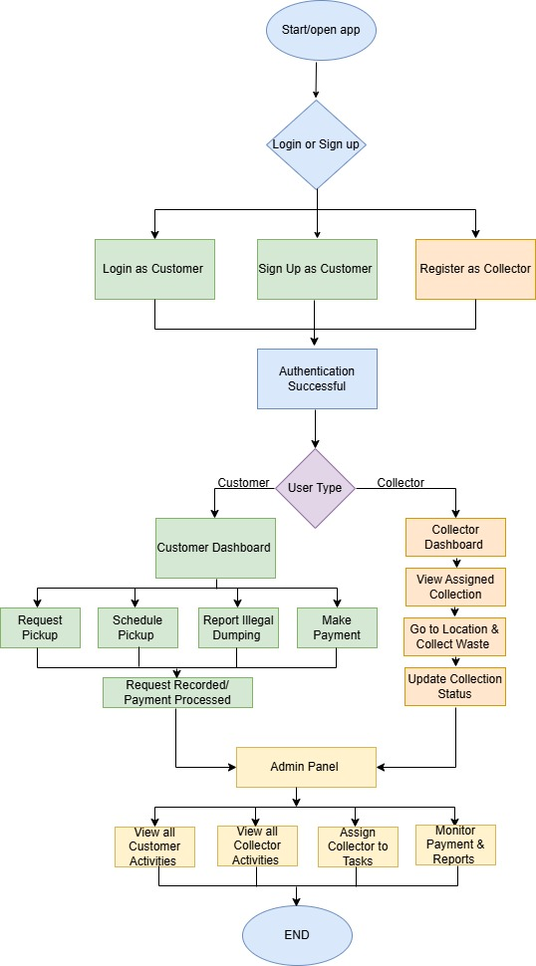
Figure 2: Flowchart

3.5.1 Entity Relationship Diagrams
Below is the entity relationship diagram in the application
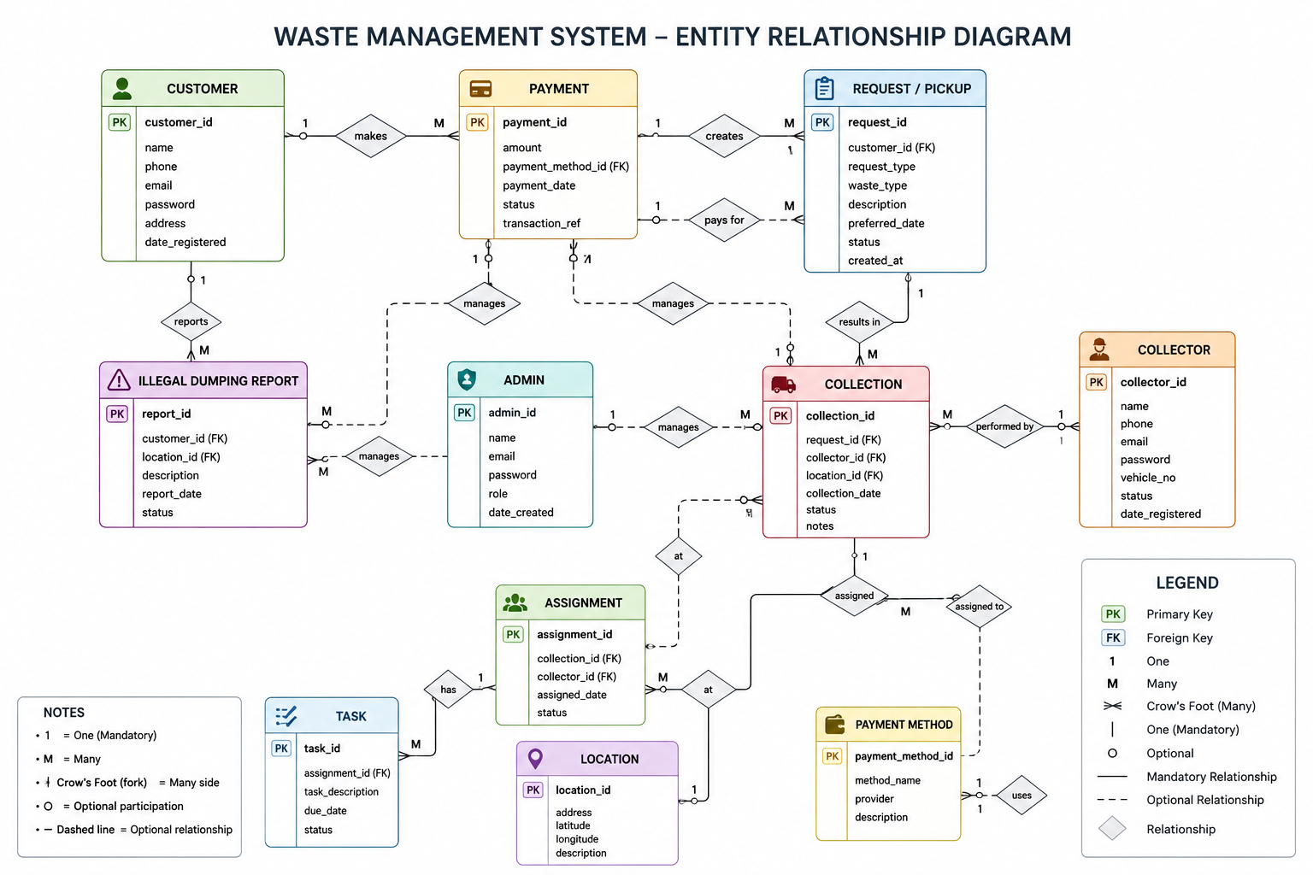
Figure 3: ER Diagram
The diagram below shows the Entity Relationship Diagram (ERD) of the Waste Management System database. Demonstrates the relationship of entities in the database. Defines the primary entities in the system - Customer, Collector, Admin, Request/Pickup, Payment, Collection, Assignment, Task, Illegal Dumping Report, Location, Payment Method. The diagram describes the process that the customers go through to register, request for waste collection, collect waste, pay and report illegal waste dumping. The administrators are responsible for assigning collection tasks to the collectors, managing customer activities and collector activities and monitoring customer payment records and collection reports. The collectors are assigned tasks, are directed to certain locations, make the waste collection and report on the waste collection.

3.6 System Requirements
During the development of the Waste Management System, necessities for the system were clearly defined to ensure optimal performance, reliability and ease of operation for the user. The requirements will be used to determine hardware and software requirements to make it possible to bring the system to life. System requirements are necessary to ensure the Waste Management System can be used effectively to manage activities like waste tracking, user management, data storage, reporting and waste collection monitoring. Precise requirements definition can also help minimize performance issues and compatibility issues with the system in a number of environments. The hardware and software requirements were discussed taking into consideration the development and implementation of the system. The requirements set are designed to make it easier for users to use the system without immediately running into problems and stumbling blocks, thereby making the system as effective and efficient as possible.
Target Audience Analysis
For the design of the Waste Management System, it's important to be known the needs and characteristics of the intended users. This involves customer identification of preference/operational needs and tech-savvy of waste management, supervisors and system administrators. These users are expected to sign into the system and perform various activities to deal with waste collection, tracking schedules and generating reports on the waste collection activities. This is done by analysing an existing waste management onto its limitations and improvement of the proposed waste management system. The current practices were studied and scope of improvement identified such as lack of record keeping, lack of real time tracking and reporting systems etc. The developed analysis was further used to develop the Waste Management System that would reportedly tackle the abovementioned issues and offer a more efficient, user-friendly and reliable waste management system that would not have been possible without the specific consideration of its users.
Platform Compatibility
Waste Management System has been developed specifically for Android mobile devices, providing the users with a convenient and easy access to waste management services. This system is built to be mobile and will be utilized on Android Smartphones & Tablets. The use of the Android platform was chosen because of its high number of users and availability. Request waste collection, collect waste planning, inform about illegal waste dumping, make payment of the waste collection fee and make waste planning and waste collection by using different ways of logins; are basic functionalities of waste management which are enabled by the system. A device running the Android operating system is needed, in order to use the Android version of Android. This app provides a way to communicate with any one of the other users consumers, waste collection men/women and administrators using mobile devices outside of work.
Hardware Requirements
The Waste Management System has been designed to be as efficient as possible by using regular computers, be available and run smoothly. The minimum system requirements are Intel Celeron (or equivalent) dual core processor, 4Gb of RAM, free storage space for data and application files is 3Gb or above. These specifications are the need to have for ensuring either the system responds perfectly without any performance difficulties when performing any of the routine tasks e.g., record management, data entry, etc., or the facility of generating the respective reports without any hassles.
Network Connectivity
Some features of the Waste Management System (such as real-time data updates, centralized reporting, monitoring etc.) may need the internet. It is recommended good internet connection (wired/wireless) is used as the system components communicating with the database should not be affected. Easy off-line data entry (especially in the event that the Internet connection is not always available) and automatic data synchronization with the Internet connection when it becomes available.
Security and Privacy
Operational and user data is sensitive and therefore security and privacy are crucial aspects of the Waste Management System. System has adopted secure authentication methods such as username and password logon and it does not allow unauthorized access. Access to the functionalities is also role based and access rights are assigned on roles. Furthermore a suitable data protection is in place to ensure that data stored is protected and conforms to corporate and data privacy needs.
User Interface (UI) Design
Among the significant points to note is that the design of the Waste Management System was geared towards a user friendly, intuitive and simple interface to make it more user friendly and efficient. The user interface was designed to be intuitive and easy to use, helping users such as waste management staff and administrators to navigate the system and perform various tasks with ease, including data entry, tracking waste, reporting, and monitoring. The design is clean and simple, features well organized layouts, clear labels and easy to access features. This allows users to use and understand the system without having to have in-depth technical knowledge. In addition, the interface was improved to make it responsive which ensures proper screen display in different screens and gadgets from within the organization. This allows users to use it successfully in their Desktop computers, laptops and get a consistent experience using it on all supported platforms.

Performance Optimization
The Design objectives of the Waste Management System was to increase the efficiency of the system, and deliver an optimized performance for users with fast response time, efficient processing and a smooth user experience. The goal of the system was to reduce the time for the data entry, retrieval and report generation, allowing users to get things done with no unnecessary delays. No excessive processing load, appropriate usage of data in the application and the system has been optimized for its performance by optimizing database queries. This means even if you have plenty of information about waste management problems, you will not have any issues with quick loading of the site, and will be responsive to the interactions with the site. Furthermore, the system had to be run with minimal system resources, due to stability in the standard system configurations. This minimizes lag or crashes of the system and guarantees the system's continuous functioning throughout the day in waste management activities.
Content Delivery
The Waste Management System was developed to ensure that all data from the system, reports and multimedia content (if applicable) is delivered efficiently and timely. The system was designed to be user friendly and easy to use to ensure that the waste collection data, user report, schedules and monitoring data can be easily retrieved by the users. Efficient Data handling method was utilized for speeding up the loading of data and to provide responsiveness to access the data from database thus enhancing performance of the system. This ensures users receive the information that they require on time, as part of their everyday activities. Optimisation techniques have also been identified as it was felt that delivery of all the report media files or attached media files each time, they were created by the system was important but would not have an impact on overall systems performance. This will ensure that there is a smooth flow and it will not cause any hassle when using Waste Management System.
Regular, formative, and summative feedback and progress tracking.
The Waste Management System has been created with tools to track progress and gather information about whether the system is working effectively to enable refinements of the system. These features enable users and administrators to monitor system functions like garbage collection logs, report generation, and system performance. Real-time feedback from the user is necessary to facilitate usability, detect system problems and increase the overall system performance. This feedback is fed-back into the system, and is used in improving and changing parts of the system, making the system more efficient, and more easy to use. Moreover, the progress tracking module can enable admin to monitor the utilization of the system, and assess system trends and the waste management system effectiveness. This will assist you in your decision making and provisioning of better services.
Testing and QA
The Waste Management system was tested thoroughly in different operating environments for its reliability, usability and functionality. The various components of the system were subjected to testing to identify and resolve bugs and yet other issues like performance and usability. Various testing methods were employed such as Unit Testing, Integration Testing and System Testing to ensure proper working of individual modules and their interconnections between them. The system has also been tested to make sure that it is efficient enough to work properly with varying workloads. A series of quality assurance activities have been incorporated in the development process to ensure that the developed system fulfil the user requirements and effective in the real-life waste management operations

3.7 Functional Requirements
The Waste Management System's very core features and attributes are described in the Functional requirements. The requirements specify the output the system shall generate to permit collection, monitoring and reporting of waste and management of waste in and through the system.
Waste Data Management
It can be utilized by users to record, update and manage data of waste collection. This includes the collection of information like waste type, quantity, location and date of collection. All the required waste related records can be stored and retrieved in the system.
Carrying out work and planning. Organising and prioritising activities and plans. The Waste Management System helps in collecting waste activities. The administration is capable of giving assignments and to arrange, monitor and track waste collection schedules of the collection for timely and efficient services.
Reporting and Analytics
The system has reporting capabilities, so that the report can be prepared on the waste management activities. These reports can be used to analyse the trend of waste output, to track performance and in decision making processes.
Monitoring and Tracking
The system also has a monitoring system, allowing administrators to monitor the waste collection process in real-time. This enables accountability and signposts what we need to step up and do to enhance services.
User Management
User role can be used to user authenticate and control the system. Access for a user to system varies depending on the role that the user has in the system.
Notifications and Feedback
System notification/feedback mechanism which notifies about update, schedule and system activities. This will enable communication and keep the users updated with respect to waste management activities.
Data Accessibility
The Waste Management System offers the possibility to store all the information required in an easy-to-retrieve format. This helps in making effective decision making and also ease the process of everyday business.
Regular Content Updates
Regular Content Updates New lessons, challenges, and features: Make the app dynamic with new content. The following rules are to be remembered: A good educational app must have the objective of engaging the user, personalizing it and creating good learning.

3.8 Non-Functional Requirements
The non-functional requirements give information about the quality attributes and the performance of the Waste Management System. The requirements make sure that the system is reliable, efficient, secure, easy to use, and that it is a working system (theoretically and practically).
Performance and Scalability
The Waste Management System is designed such a way that it would respond instantly to the users' commands so that within a short period of time various tasks like data entry, retrieval and report etc. could be accomplished. The system is also scalable, which means that it can be expanded to store more data and more users but won't affect the speed or performance of the system.
Useability and User Experience (UX).
The system is designed to be user-friendly and easy to use, with a simple and intuitive interface that helps waste management staff and administrators to navigate and access the system easily. Clear navigation, well-structured layout and appropriate labelling of features has enhanced navigation and made it more user friendly. The system is also easy to use and doesn't require extensive technical skills.
Information security and Data Protection.
Waste Management System has security as one of the critical needs. The system is secure, using logins and role-based access control (RBAC) for the safety of sensitive information. Confidentiality is maintained for all information and systems use data protection measures such as secure data storage, secure integrity and secure alteration to ensure that the information is not subjected to access by unauthorised persons, subject to alteration or cannot be lost.
Reliability and Availability
To ensure the operational capacity is always available in a waste management system to be applied every day. It will be expected to be operational with minimal downtime to ensure it can effectively track, report and monitor waste at all times. Error handling is also available to handle gracefully in case although something goes wrong in the system, the user is notified.
Capacity and Data Limits
The goal of Waste Management System is to manage a lot of data about waste collection, user data and reports. It can support many users to utilize it concurrently and present services efficiently in high utilization operational environments without any problem.
Compatibility
This system is inserted in the common running systems, including organization running system (OS is mainly Windows Host). Designed to work best in the various environments of different users: desktop and laptop.

3.9 System Design
The design of Waste Management System identified through this evaluation is vital to the effective collection, monitoring, reporting and data management of waste. The overall design is well balanced and harmonious, with all the elements functioning well and complementing each other.
User Authentication
It can come with security features for authenticating any identity that will only be allowed for authorized users to access the system. Access is controlled by the username/password and different users (admin or staff) have access to different functions by using role-based access control.
Consumption and Disposal of Waste.
It is utilized for monitoring waste tracking information like collection data, location of the waste, quantity collected, garbage collection schedule and information about users. All of the data in each data module is presented in an organized manner, making it easy to enter, manipulate, retrieve and organize.
The last task is to analyse data.
The system is efficient to manage waste management data as well as to generate fruitful reports. These reports provide information on waste collection patterns, performance and efficiency, and assists with making knowledge-driven decisions.
Monitoring and Tracking
The system has a number of tracking capabilities for waste collection activities and tracking operational progress. This will help administrators to evaluate performance and ensure that waste management activities are carried out effectively and on time.
Communication and notification capabilities.
The Waste Management System offers several ways to notify the users of planned changes and other activities performed by the system. This improves communication, and facilitates waste management by managing waste on time.
Scalability and Performance
The system is scalable, both in terms of volume of waste data and number of users planned to be designed to be able to operate with a high performance even when the volume or number increases. Efficient database queries and structuring data are used for optimisation to guarantee responsiveness and reliability even under heavy usage.
System Integration
The design is such that it can be easily integrated with other parts of the system, such as user management, data storage, reporting and monitoring. This makes sure the interaction of the parts of a system and improves system efficiency.

CHAPTER 4

SYSTEM IMPLEMENTATION AND RESULTS

4.0 Introduction
The users will end up with some functions and capabilities after using the Waste Management System. The requirements of this system are described in the system requirements comprising the function that the system should perform and how the system should behave in different situations. In this chapter the requirements of the Waste Management System are presented including functional as well as non-functional requirements. Functional Requirements are brief descriptions of services that the system provides, operations it can perform on and data it can record and report; e.g., waste collection management, data recording, reporting and user management. Non-functional requirements are the attributes of the system such as: Performance, Security, Reliability, Usability. The requirements are applied to the developed system to check if the needs of the waste management personnel, the waste management manager and other stakeholders are met, and whether an efficient and sustainable waste management has been achieved.

4.1 Sign Up Page/ Login Page
Create Your Account
Sign Up Page enables new users to sign up and access the Waste Management System. The procedure for registering is simplified, secure and easy-to-use. The use of a user name which should be composed of alphabetic and numeric characters of the users' choice is required. Your username will be recognized and use this as an access there. To enhance security on the system, users MUST use a password that consists of a minimum of 6 (six) characters including letters, numbers and any special characters (e.g. Waste@123). This will help to maintain the security and security of user accounts. Full Name: The system recognizes and identifies the user by his/her full name. Email Address: A valid email address is required to help communicate, verify accounts and reset passwords. Users may be granted one of several roles (as a function of the settings of the system) that enable the user to gain access to the system. Depending on the configuration of the system, users can be assigned a role in the system, such as Administrator, Waste Management Officer or Staff member, that will give them access to differing parts of the system. Once users enter all of the required information, they click the Sign Up button to sign up and log in to the Waste Management System. Registration Successful, if it is successful, it enables user to access and use activities related to waste, view waste reports generate other functionality based on register roles.
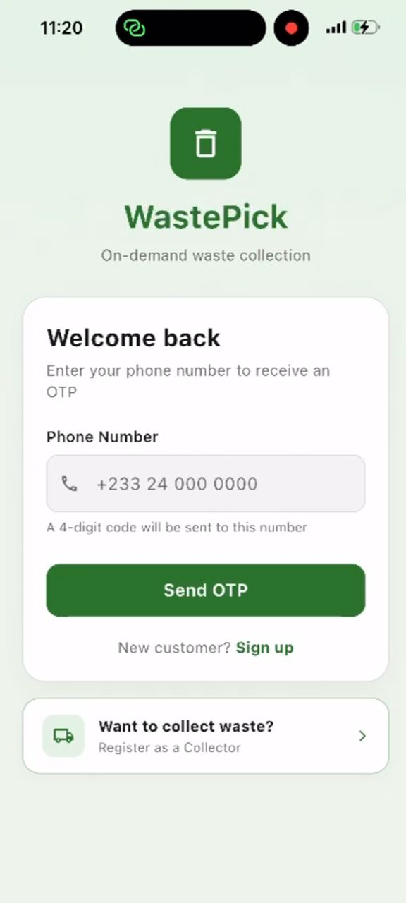
Figure 4: Signup/Login Page

4.2 Customer Dashboard
The Customer Dashboard is the main page of the Waste Management System, which provides users with a user-friendly and organized view of their waste management operations. The dashboard is designed to help customers easily maneuver through the proposed system. Through the dashboard, customers will be able to make new service requests, review existing waste requests, view their waste history, and receive important information regarding the progress of the waste control system and service reminders. In addition, the dashboard provides some vital information including the number of pickups requested, number of services completed, and number of pickups pending. The Customer Dashboard features a user-friendly interface with easy navigation, which makes it easy for customers to manage their waste disposal needs and navigate the Waste Management System smoothly and conveniently.
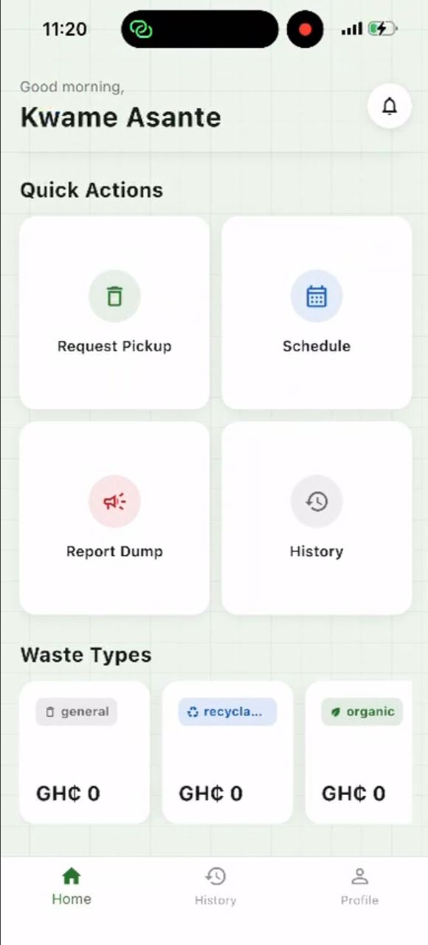
Figure 5: Customer Dashboard

4.3 Request Pickup Page
The Request Pickup Page enables the user to easily select pick-up dates for waste services through the Waste Management System, via the Request Pickup Page. The feature can be used by users to notify the team to pick up the waste if necessary, including relevant information to help optimize waste collection and disposal. The waste type to be collected can be specified by the user, depending on the system's type: Household waste, recyclable waste, organic waste or other types of waste. They should also show their address where they are to be picked up, time they are to be picked up and any other information that they may find useful for the pickup of something. If triggered, all the data is stored in the system, and sent to the waste management personnel for processing. Then, the users would be able to follow the status of their requests and confirm whether the collection has been processed or not and also be notified of the time in which it would be processed and updates about the collection would also be given to them. If it is intended, then the purpose of the Service History section should be to give the user the complete history of all waste management services called for and put into practice through the system. This will allow consumers to view and track all their waste collection activities, and stay informed about their waste disposal history. The important information for each of the data of the services is: Date requested for pick up, Type of waste, Where the waste is picked up, Date waste is picked up and whether it is picked up or not. Completed, pending and cancelled requests are shown and will be available at all times, helping to promote waste management transparency and accountability.
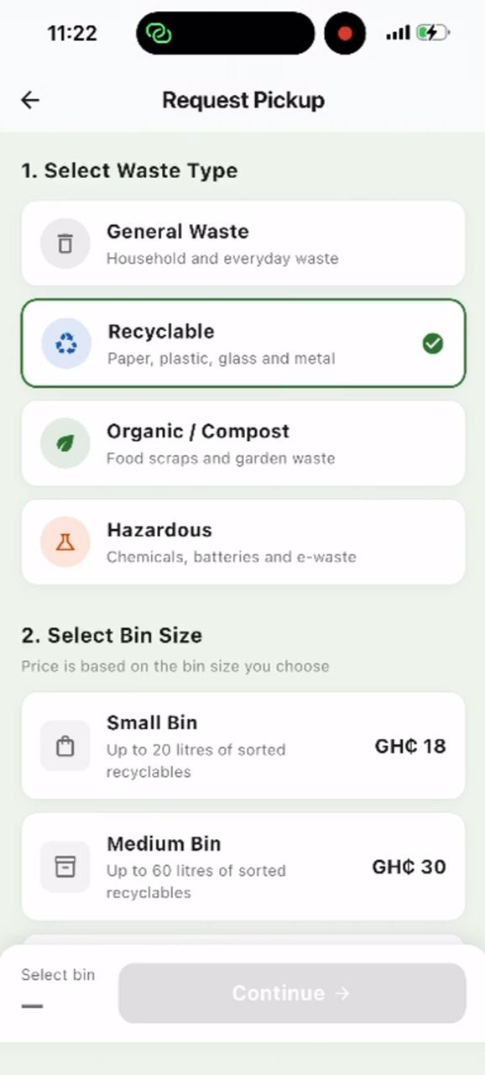
Figure 6: Request Pickup Page

4.4 Service History
Another advantage of the Service History section is that it may be beneficial for monitoring both attainment of satisfactory service completion and maintenance records for all waste removal operations conducted on the site by administrators and the waste management team. Easy access to historical data improves the system's usability, and helps in planning, reporting and decision-making, by making it easy to access data when decisions have to be made.
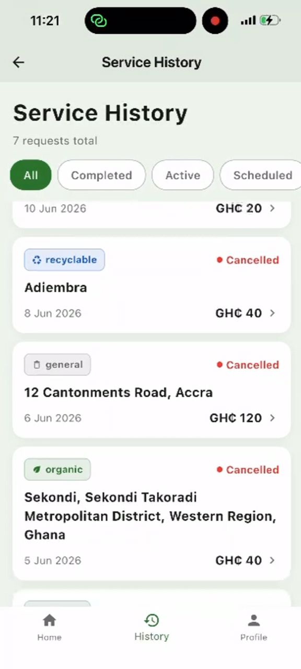
Figure 7: Service History

CHAPTER FIVE

CONCLUSION

5.1 Conclusion
The world is now facing a challenge of waste management because of the growing population, urbanization and industrialization. Of course, the traditional waste management strategies are not effective, as there are many factors including waste collection delay, lack of operational information, poor use of TCHS records, and access to reliable data (Kaza et al., 2018, UNEP, 2021). All these challenges again highlight the importance of any technology-based solution that can optimize the existing waste management process and help to achieve environmental sustainability (Kumar et al., 2020).
The functionalities of the proposed Waste Management System have been properly integrated into the design and development which has led to enhanced effectiveness and efficiency in waste management operations. The system provides secure authentication for users, requests for waste collection, history of services provided, reporting and monitoring. The features allow users and waste management staff to effectively organize and run waste collection operations with the ability to keep proper records and increase transparency and accountability (Singh & Kumar, 2020).
In addition, the system offers the opportunity for timely collection of waste with the request pickup function, thus allowing users to conveniently organize waste collection. There is a reporting and tracking level that adds to the percentage of oversight and strengthens the information for decision-making. The system has the potential to be successfully utilized in digitalizing the waste management system and it has already been proven that the system can alleviate some of the shortcomings associated with manual systems of waste management records and result in improved service provision (Batool & Ch, 2019).
Security, reliability, usability and scalability come to mind as other critical Non-Functional Requirements (NFRs) for the Waste Management System. The capabilities also guarantee the security, availability and scalability of the system as more customers and waste management operations join in the system, which is highly exponential (Pressman & Maxim, 2020).
Lastly, the Waste Management System proposed is a technological solution which is effective in managing activity related with waste collection and disposal. The system would bring with it better operational efficiency, better provision of services, and environmental sustainability – which are all three important improvements in waste management in the modern system, and all contribute to cleaner and healthier communities, in accordance with World Bank (2021) and OECD (2021).

5.2 Future Works
The following are a few recommendations and suggestions on how to improve the future versions of Waste Management System:
- They should make it possible to track the garbage trucks by using GPS technology in order to effectively monitor and manage their location in real time.
- System should include Payment Online Gateway to enable users to easily pay for Waste Collection Services.
- SMS and email notification features should be implemented for the system, thus user will get information regarding the pickup schedule as well as the status of the system.
- It should have sophisticated analytics and dashboard capabilities to more effectively track trends and operational performance in the generation of waste.
- The system should offer recycling management functions to foster waste segregation, and to promote the environmental sustainability initiatives (Geissdoerfer et al., 2020).

REFERENCES
- Agyeman, F., & Boateng, E. (2023). Mobile-based sanitation reporting and citizen participation in Ghana. Sustainable Cities and Society.
- Asare, W., Mensah, J., & Owusu, K. (2021). Urban solid waste management challenges in Ghana. Journal of Environmental Management.
- Banguera, L., Sepúlveda, J., & Fuentes, M. (2021). Smart waste management systems and sustainability. Waste Management Journal.
- Geissdoerfer, M., Savaget, P., Bocken, N., & Hultink, E. (2020). The circular economy. Journal of Cleaner Production.
- Kaza, S., Yao, L., Bhada-Tata, P., & Van Woerden, F. (2021). What a Waste 2.0. World Bank.
- Kumar, A., Agrawal, A., & Sharma, V. (2020). Smart waste management technologies. Environmental Technology Review.
- Longhi, S., Marzioni, D., Alidori, E., & Buo, G. (2020). Smart waste collection systems. Sensors Journal.
- OECD. (2021). Waste management and the circular economy.
- Singh, J., & Kumar, R. (2020). Technology-driven waste management systems.Environmental Science Review.
- UNEP. (2021). Global waste management outlook. UNEP. (2022). Waste management and climate change.
- Wilson, D., Velis, C., & Cheeseman, C. (2020). Role of waste management in sustainable development. Waste Management Journal.
- World Bank. (2021). Municipal solid waste management strategies.
Yadav, P., & Samadder, S. (2020). Public participation in waste management. Waste Management Research.
- Zhang, D., & Chen, M. (2021). Digital technologies in waste management. Journal of Cleaner Production.
- Beck, K., Beedle, M., van Bennekum, A., Cockburn, A., Cunningham, W., Fowler, M., Grenning, J., Highsmith, J., Hunt, A., Jeffries, R., Kern, J., Marick, B., Martin, R. C., Mellor, S., Schwaber, K., Sutherland, J., & Thomas, D. (2001). Manifesto for Agile software development. https://agilemanifesto.org/
- Batool, S. A., & Ch, M. N. (2019). Municipal solid waste management in developing countries: A case study. Waste Management, 95, 1–10.
- Geissdoerfer, M., Savaget, P., Bocken, N. M. P., & Hultink, E. J. (2020). The circular economy–A new sustainability paradigm? Journal of Cleaner Production, 143, 757–768.
- Hoornweg, D., & Bhada-Tata, P. (2018). What a waste 2.0: A global snapshot of solid waste management to 2050. World Bank.
- Kumar, A., Samadder, S. R., & Singh, R. (2020). Intelligent waste management systems: A review. Environmental Monitoring and Assessment, 192(6), 1–18.
- Moe, N. B., Dingsøyr, T., & Dybå, T. (2018). Understanding self-organizing teams in Agile software development. Information and Software Technology, 77, 34–45.
- OECD. (2021). Global waste management outlook. Organisation for Economic Co-operation and Development.
- Pichler, R. (2019). Agile product management with Scrum. Addison-Wesley.
- Sharholy, M., Ahmad, K., Mahmood, G., & Trivedi, R. C. (2018). Municipal solid waste management in Indian cities. Waste Management, 28(2), 459–467.
- Singh, J., & Kumar, S. (2020). Smart waste management systems using IoT. Journal of Cleaner Production, 255, 120–135.
- Sutherland, J., & Schwaber, K. (2019). The Scrum guide. Scrum.org.
- UNEP. (2021). Global waste management outlook 2021. United Nations Environment Programme.
- Wilson, D. C., Velis, C. A., & Cheeseman, C. (2020). Role of informal sector recycling in waste management. Waste Management, 29(4), 171–176.
- World Bank. (2021). What a waste 2.0: A global snapshot of solid waste management to 2050. https://www.worldbank.org/
- Yadav, P., & Samadder, S. R. (2020). Waste management and public participation. Journal of Environmental Management, 260, 110–120.
- Zhang, Y., & Chen, X. (2021). Smart city waste management systems: A review. Sustainable Cities and Society, 65, 102–112.
- Batool, S. A., & Ch, M. N. (2019). Municipal solid waste management in developing countries: Challenges and opportunities. Waste Management Journal, 95, 1–10.
- Geissdoerfer, M., Savaget, P., Bocken, N. M. P., & Hultink, E. J. (2020). The circular economy – A new sustainability paradigm? Journal of Cleaner Production, 143, 757–768.
- Kaza, S., Yao, L., Bhada-Tata, P., & Van Woerden, F. (2018). What a Waste 2.0: A global snapshot of solid waste management to 2050. World Bank.
- Kumar, A., Samadder, S. R., & Singh, R. (2020). Smart waste management systems and their role in sustainable development. Environmental Monitoring and Assessment, 192(6), 1–18.
- OECD. (2021). Global waste management outlook. Organisation for Economic Co-operation and Development.
- Pressman, R. S., & Maxim, B. R. (2020). Software engineering: A practitioner's approach (9th ed.). McGraw-Hill Education.
- Singh, J., & Kumar, S. (2020). Smart waste management systems using information and communication technologies. Journal of Cleaner Production, 255, 120–135.
- UNEP. (2021). Global waste management outlook 2021. United Nations Environment Programme.
- World Bank. (2021). What a Waste 2.0: A global snapshot of solid waste management to 2050. World Bank Publications.
- Kannan, D., Khademolqorani, S., Janatyan, N., & Alavi, S. (2024). Smart waste management 4.0: The transition from a systematic review to an integrated framework. Waste Management, 174, 1–14.
- Singh, J., El-Sappagh, S., Ali, F., Goyal, S. B., & Kumar, M. (2025). Smart waste management: A systematic review and scientometric analysis of artificial intelligence applications. Environment, Development and Sustainability (in press).
- Sosunova, I., & Porras, J. (2022). IoT-Enabled Smart Waste Management Systems for Smart Cities: A Systematic Review. IEEE Access, 10, 73326–73363.
- Wirani, Y., Eitiveni, I., & Sucahyo, Y. G. (2024). Framework of Smart and Integrated Household Waste Management System: A Systematic Literature Review Using PRISMA. Sustainability, 16(12), 4898.

